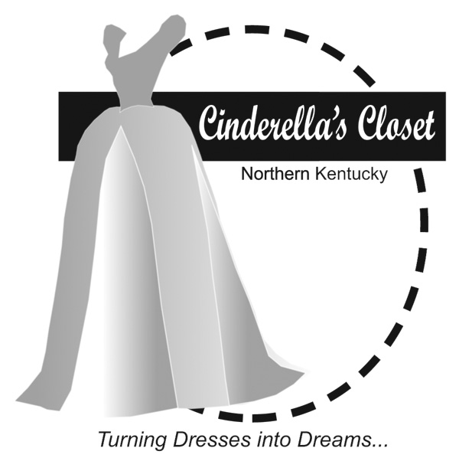

Cinderella's Closet provides formal wear to girls who could not otherwise attend their prom. Through donations of new and gently used formal dresses and accessories, Cinderella’s Closet Purchase Area Community will "Turn Dresses Into Dreams" for juniors and seniors who will be referred to our organization by their school. Even more than a dress, Cinderella's Closet will provide an unforgettable, amazing experience.  From the moment princesses dance through our doors, they will be greeted with an environment of grace, love and respect. On April 16, 2016, we will host the first Cinderella’s Closet of the Purchase Area Community to help the young ladies of Paducah and McCracken County. Please help ***Turn Dresses Into Dreams.***

**How can you help?**

* **DONATE** *(all donations are tax deductible)*
  + Donate gently used or new formal gowns, shoes, purses and jewelry
  + Make a monetary donation to help purchase items not donated in the quantities needed (i.e. plus size dresses and shoes)
* **VOLUNTEER**
  + Organize a dress drive at your school, work or church
  + Host a Cinderella’s Closet party to collect dresses and accessories
  + Be a Fairy Godmother and work one on one with our princesses to find the dress of their dreams (ladies age 20 or older)
  + Make a commitment to be on our organizing committee

**Find out more about this ministry:**

**On Facebook: Cinderella’s Closet Purchase Area Community**

**For more about our history visit: www.cinderellasclosetusa.org**

**or call 270.556.2682**

Cinderella’s Closet

Turning Dresses Into Dreams